**Project Two**

System Design Document

Sharif Ayesh

CS-255

Christopher Eppenger

02/20/2025

# CS 255 System Design Document

This template lays out all the different sections that you need to complete for Project Two. Each section has guidance to prompt your thinking. You will need to continually reference the interview transcript as you work to make sure that you are addressing your client’s needs. There is no required length for the final document. Instead the goal is to complete each section based on what your client’s needs are. Remove this note when you are finished, and replace all bracketed text with the relevant information.

## UML Diagrams

### UML Use Case Diagram

### UML Activity Diagrams

### A diagram of a computer program

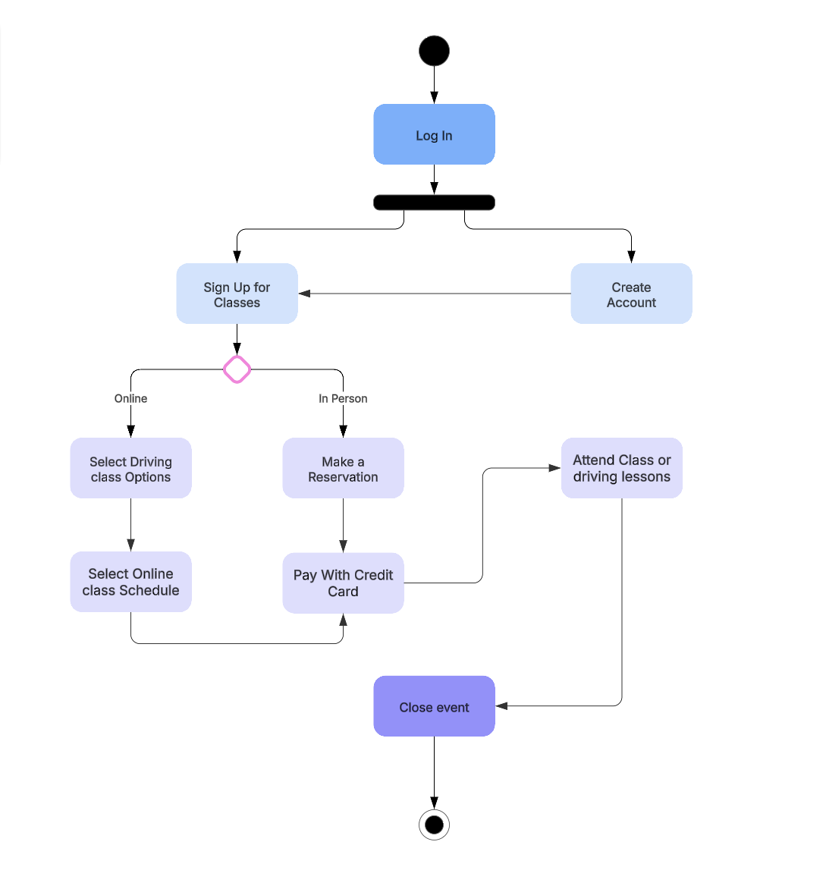

### UML Sequence Diagram

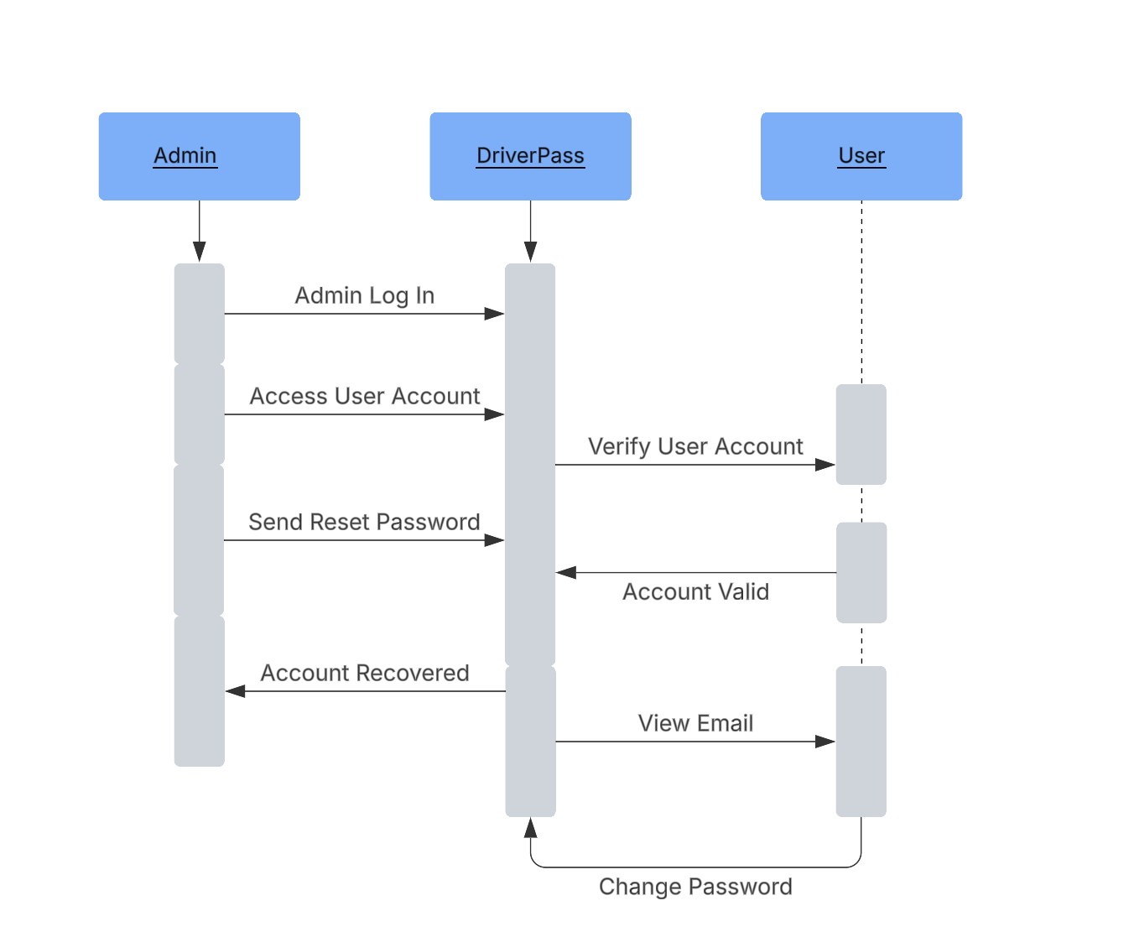

### UML Class Diagram

## Technical Requirements

**Technical Requirements**

Based on the system design, the following are the technical requirements necessary to support the implementation and functionality of the system. These requirements encompass the necessary hardware, software, tools, and infrastructure to ensure optimal performance and security.

**Hardware Requirements for Host:**

* At least one physical or cloud-based server
* Networking cables or wireless networking equipment
* Monitor, keyboard, and mouse for system administration
* Power sources or backup power supply (UPS)
* High-speed internet connection with a reliable provider

**Hardware Requirements for Client:**

* Desktop or laptop computer
* Wi-Fi router or Ethernet cable for networking
* Power supply and surge protection
* Internet access with sufficient bandwidth

**Software Requirements for Host:**

* Server operating system (Windows Server, Linux, or cloud-based OS)
* Virtualization software (Docker, VMware, or equivalent)
* Security software for protection against cyber threats
* Database management system (MySQL)
* Web server software (Apache, Nginx, or similar)

**Software Requirements for Client:**

* Web browser application (Google Chrome, Firefox, Edge, etc.)
* Operating system (Windows, MacOS, or Linux)
* Security software for endpoint protection

**Tools Required for Development:**

* Integrated Development Environment (IDE) such as PyCharm, Visual Studio Code, or Eclipse
* Version control system (Git/GitHub)
* Database management tools (phpMyAdmin, DBeaver, or pgAdmin)
* API testing tools (Postman or equivalent)
* Network monitoring tools for traffic analysis

**Infrastructure Requirements:**

* Cloud hosting provider (AWS, Azure, or Google Cloud) or on-premises server setup
* Secure authentication and access control mechanisms
* Backup and disaster recovery solutions
* Load balancing and scalability support